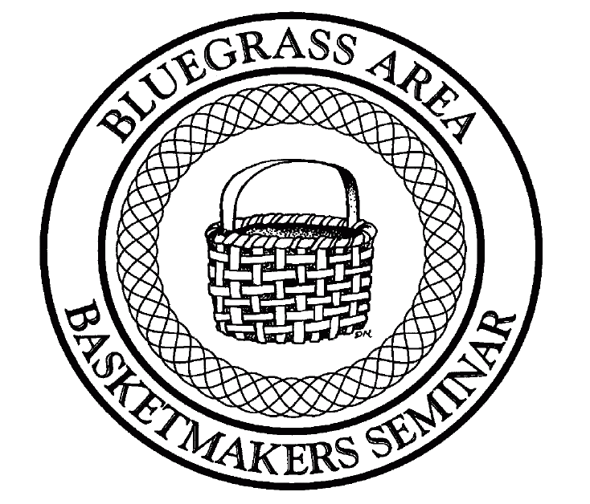
Bluegrass Area Basketmakers Seminar
Carrollton, Kentucky
June 17-21, 2025

Sponsored by: Bluegrass Area Counties Cooperative Extension Service

Dear Potential Teacher,

The Bluegrass Area Basketmakers Seminar will hold its 29th Annual event June, 17-21, 2025 at the General Butler Resort State Park in Carrollton, Kentucky. This is promoted as a quality workshop with professional teachers, quality materials, and baskets. We hope that you will consider submitting to teach at this very special basket weaving seminar. Please do not submit any classes that you have already taught or plan to teach at another convention/retreat in Kentucky during the year 2025.
Classes will begin on Tuesday afternoon June 17th at 1:00 p.m. Eastern time and will continue through Saturday afternoon.
We accept on-line submissions as well as hard copy mail in proposals. On-line submissions do not require you to make copies of the form, only that you fill in the on-line submission form for each basket you submit. See detailed instructions at www.babasketmakers.org.
If you choose to submit by hard copy mail-in submissions please visit our website and print copies of the complete submission forms for each of the classes you wish to teach. You will need a separate form for each class proposed. Note that the form requires a detailed description of your basket (i.e., size, price, length of class, and any special tools needed.) Please note on the form whether you wish to teach part time or every day, and how late you are willing to teach. We also need a photograph (digital photo preferred) of each basket you submit.
The deadline for submissions is October 1, 2024. Baskets will be juried at our October meeting. All teachers that are accepted will be notified in November once the class schedule has been made. There has been a lot in interest shown by both teachers and students, so please respond as soon as possible. Because of limited teaching spaces and in order to facilitate full classes for our teachers, we will be accepting 10 or fewer teachers for 2025. Each teacher selected, and teaches all five days, will receive a $200 stipend from the committee to help cover rooming expenses.
The Bluegrass Area Basketmakers committee would like to thank all our teachers for the continued support and promotion of our Seminar. We couldn’t have this wonderful event without you. Thank you.

If you have any questions, you may contact us at:

Marty Wright
120 Goodlett Kilner Ct.
Mt. Washington, KY 40047
martybobky@gmail.com
859-338-6100

Would you be interested in teaching a technique for 1 or 2 classes at night? ______ yes ______ no
If yes, please submit pictures, descriptions, etc.

Brief teacher biography in 100 words or less as you would like to have it printed in the catalog if you are selected. (This needs to be filled out only once if you are submitting more than one basket.) Also, please provide us with a personal picture of yourself for the 2025 catalog.

We look forward to having you submit your pictures. Please note that submitting pictures does not guarantee acceptance. The classes are chosen by a panel of basketmakers. You will be notified by December, 2024 if your classes have been accepted for the Basketmakers Seminar 2025.

Send your pictures along with the required information to:

Marty Wright
120 Goodlett Kilner Ct.
Mt. Washington, KY 40047
martybobky@gmail.com
859-338-6100

Teacher Proposal
Bluegrass Area Basketmakers Seminar
Carrollton, Kentucky
June 17-21, 2025

Please fill out a separate form for each basket submitted.

Teacher Basket

Name _____________________________ Name ___________________________
Address ___________________________ Size _____________________________
__________________________________ Price ____________________________

Telephone ________________________ Weaving Level _____ Beginning
_____ Intermediate
__________________________________ _____ Advanced
_____ All Levels

E-Mail address: _________________________________________________________________

Special tools needed: _____________________________________________________________

Hours needed to make basket: _____ 2 hours _____ 4 hours

_____ 6 hours _____ 8 hours _____ 12 hours

Seminar will last 5 days, do you wish to teach: _____Tuesday _____Wednesday

_____Thursday _____Friday _____Saturday ______Evening classes

How late are you willing to teach? _______________________________________________
Include a short description of the basket as you would like to have printed in the catalog if you are selected.

Place Picture of Basket Here

Please place measurement reference such as a ruler when taking picture.
(Solid white background in picture makes basket show up better in the catalog)

Picture will be returned by mail or at the Basket Seminar.

Information must be postmarked by October 1, 2024. Later postmarks will not be accepted.

